FOR IMMEDIATE RELEASE

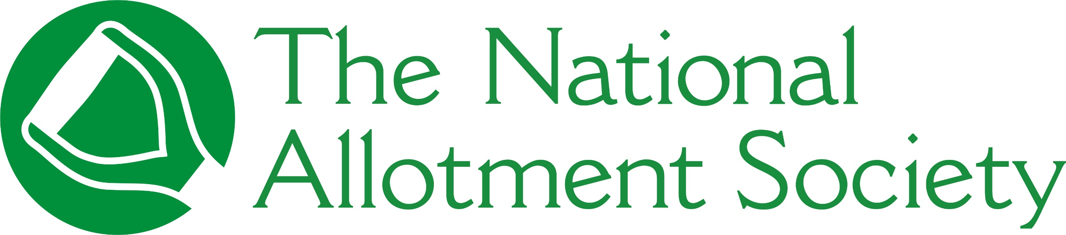

PRESS RELEASE

Tuesday 3rd November, 2026

Gardener and author Huw Richards named National Allotment Society Ambassador

The National Allotment Society (NAS), the UK’s leading representative body for allotment holders, has appointed gardener, author and content creator Huw Richards as its newest Ambassador.
In his new role, Huw will use his passion for growing food in productive, sustainable and nature-friendly ways to champion allotment gardening and help more people discover the practical, social and environmental benefits these vital spaces offer.
Huw is renowned for showing what can be achieved in a small growing space. His 125-square-metre allotment produces around 7,000 portions of fruit and vegetables towards the recommended five-a-day — enough for a family of four for a year. Inspired by his dad, he began gardening at a very young age and started making YouTube videos about food growing when he was 12.
Of his appointment, Huw said: “Allotments represent so many things I care about – growing food, sharing knowledge, sustainability, community and making productive use of small spaces, so I was delighted to be asked to be an Ambassador.
“Allotments give people an opportunity to grow fresh food, spend time outdoors, develop practical skills and understand where their food comes from. They're places to learn, experiment, meet people, connect with nature and spend time away from everyday pressures.
“They're also places where knowledge is passed on. Someone who has been growing for 50 years can work alongside somebody who has just taken on their first plot.
“But success isn't only measured in kilograms of food. It's also about creating somewhere you genuinely want to spend time.”
Commenting on Huw’s appointment, Mike Farrell, Chair at NAS, said: “We’re proud to have Huw onboard as an Ambassador and know that our members will benefit from his extensive knowledge and expertise.
“Indeed, Huw recently joined us at our AGM where he demonstrated how thoughtful planning, good soil and the right crops can turn even a modest growing space into an extraordinarily productive allotment.”
Huw joins NAS’s fellow Ambassadors, including RHS multi-award-winning garden designer Zoe Claymore, horticulture lecturer and Head Gardener at Rudding Park Hotel & Spa Sarah Owen-Hughes, garden designer and Gardeners’ World presenter Adam Frost and Youth Ambassador Finn Young.
For more information about The National Allotment Society, visit https://thenas.org.uk

[ENDS]

Please direct any press enquiries to Emma Speirs on 01536 682800 or email emma.speirs@ballyhoo-pr.co.uk

NOTES TO EDITORS

Pictured is Huw Richards, NAS’ newest Ambassador

About The National Allotment Society
With over 133,000 members, The National Allotment Society (NAS) is the leading representative body for UK allotment holders. Its mission is to protect, promote and preserve allotments for future generations.

NAS works with allotment sites, associations, councils and individual plot holders to provide advice and guidance on a range of issues including site management, environmental concerns, tenancy agreements and fundraising.

For more information, go to https://thenas.org.uk/ or follow NAS on Facebook and Instagram

